**ACM Education Board and Education Council**

**FY2017-2018**

**Executive Summary**

This report summarizes the activities of the **ACM Education Board and the Education Council[1]** in FY 2017-18 and outlines priorities for the coming year. Major accomplishments for this past year include the following:

**Curricular Volumes:**

Joint Taskforce on Cybersecurity Education

CC2020

**Completed**:

Computer Engineering Curricular Guidelines 2016 (CE2016)

Enterprise Information Technology Body of Knowledge (EITBOK)

Information Technology 2017 (IT2017)

Masters of Science in Information Systems 2016 (MSIS2016)

**International Efforts:**

Educational efforts in China

Educational efforts in Europe/Informatics for All

**Taskforces and Other Projects:**

Retention taskforce

Learning at Scale

Informatics for All Committee

International Education Taskforce

Global Awareness Taskforce

Data Science Taskforce

Education Policy Committee

NDC Study

**Activities and Engagements with ACM SIGs and Other Groups:**

CCECC

Code.org

CSTA

SIGCAS

SIGCHI

SIGCSE

SIGHPC

SIGGRAPH

SIGITE

**Other Items:**

Education Board Rotation

Education Council Rotation

**Future Initiatives**

Global Awareness Taskforce

International Education Framework

**Highlights**

This is a very short list of the many accomplishments of the year. For full view of the work to date, please see Section One: Summary of FY 2017-2018 Activities.

**Diversity Taskforce:** The Taskforce expects to complete its work by early 2019. Their goals of

* Exploring the data challenges
* Identifying factors contributing to the leaky pipeline
* Recommending potential interventions to improve retention

**Learning at Scale:** The Fifth Annual ACM Conference on Learning @ Scale (L@S) was held in London, UK on June 26-28, 2018. The Learning @ Scale conference is underwritten by the Education Board (rather than a SIG) as the conference was originally conceptualized by the Education Board.

This year the conference was part of a weeklong London Festival of Learning where L@S 2018

was co-located with the International Conference of the Learning Sciences and the Artificial

Intelligence in Education Conference.

**NDC survey:** The results of the 2016-17 study, conducted in fall 2016 and winter 2017, were published in the September 2017 issue of ACM *Inroads*.

**Curricular Volumes:**

**CC2020**: Computing Curricula 2020 (CC2020) is a joint project launched by professional computing societies to examine the current state of curricular guidelines for academic programs granting degrees in computing and to provide a vision for the future of computing. The goal of the initiative is to produce a comprehensive report and interactive website that compares and contrasts these guidelines to situate and contextualize them in the landscape of computing education. Ultimately, the project strives to help programs to prepare graduates both academically and professionally to meet the challenges in the 2020s. The international project team represents organizations from academia, industry, and government.

**Data Science curriculum effort**: This effort has been modified to a Taskforce on Data Science. They are finalizing the initial draft of a curricular report, expected release for comment Fall, 2018.

**Education Policy Committee:** The ACM Education Policy Committee operates mainly through email discussions among the members. The primary staff support, Renee Dopplick, left ACM in July 2017. In October 2017, EPC became a standing committee under the ACM Education Board. With transitions in leadership of ACM and uncertainty about the committee’s status, the EPC has been on hold with no new members appointed. The last in-person meeting was June 24, 2016.

After careful review, it was determined that there are currently no appropriate projects for this committee. The Education Policy Committee was put on inactive status until an appropriate project is identified.

**International Framework Taskforce** is a new initiative to develop a framework to formalize the ACM Education Board/Council’s connection with global organizations in order to improve the flow of global information to ACM Education Council members.

**Jointed Taskforce on Cybersecurity Education**: Completed

**Education Board and Council Rotation:** The Education Board and Council rotation process was delayed this year due to the ACM executive board elections and the need for the new president to understand our process.

Impact:

* The Education Council was re-named as the Education Advisory Committee.
* The appointment of the Education Board co-chairs was delayed. This delay caused a major delay in the writing and publishing of the 2018 Annual Report.
* The appointment and re-appointment of Board and Council/Committee members was also delayed.

**Section One - Summary of FY 2017 Activities**

**Education Board Strategic Priorities**

The following were identified as strategic objectives for the Education Board (they were later agreed to by the Education Council at its meeting in Miami in February 2011 and continue today):

* To provide a focus for ACM activity and leadership in the general area of computing education
* To support the ACM’s strategic objectives through activities and initiatives in computing education; this includes providing support for ACM’s various Councils
* To understand the education related needs and aspirations of ACM members—students, academics, practitioners (and their managers) and employers—and to respond appropriately on behalf of ACM
* To provide leadership for the computing community in curricular development and curricular guidance; the community is to include all levels of education (specifically including K-12 and two-year college activity) with the emphasis being on higher education
* Where possible to act on behalf of the computing community to increase the status and standing of computing education
* In recognizing ACM’s role as an international organization, to understand the differing needs of the international community and to address these in Education Board and Education Council considerations
* To organize and manage meetings of the Education Council, to keep the Council members up-to-date with significant developments and generally to manage the work of the Council
* To approve ACM appointments to education-related bodies such as ABET, and to keep informed about and engage in significant related activity

**Current priorities**

At a meeting of the Education Council, Portland OR, August 2018, the following priority areas had been reviewed and will be continued, namely supporting

* International Outreach
* Diversity
* Curricular guidelines
* Computing Terminology
* K-12 Computing

In addition, the new/expanded priorities for FY2019 include all of the above with the addition of data science and CC2005/CC2020 to the curricular priority areas and the exploration of Computing Education as related to Ethics and Social Responsibility, How to Enable Higher Education to Better Serve the Diversity of Computing Preparation Entering Higher Education.

**Education Council FY2017 Activities**

The current work of the Education Council is detailed below by activity with task membership, current status and lessons learned. Future plans can be found in Section 2.

**Projects & Taskforces**

**Learning at Scale**

ACM Education Board/Education Council representative: Mehran Sahami

The Fifth Annual ACM Conference on Learning @ Scale (L@S) was held in London, UK on June 26-28, 2018. The Learning @ Scale conference is underwritten by the Education Board (rather than a SIG) as the conference was originally conceptualized by the Education Board. This year the conference was part of a weeklong London Festival of Learning where L@S 2018 was co-located with the International Conference of the Learning Sciences and the Artificial Intelligence in Education Conference.

The L@S conference had 115 attendees. This is a lower rate of attendance than last year (when the conference was held at MIT), but in line with prior years where the conference was held in a non-North American venue. With respect to revenue, the conference was essentially break even. As part of the agreement to take part in the Festival of Learning, we agreed that the conference would have no financial downside risk (i.e., we would not have to take any losses in the event that the conference was revenue negative) if we were willing to share the potential conference upside with the other co-located venues. In the end, we did not incur and any real gains or losses.

Given surpluses from the prior four conferences, Learning @ Scale is projected to have a total surplus of roughly $94,000 after the fifth conference in the series. So, the conference still seems quite viable financially.

**NDC survey**

ACM Education Board/Education Council representative: Yan Timanovsky, Jodi Tims, Stu Zweben

This annual survey provides data to the computing community on Degree Production, Enrollments, and Faculty from Bachelor’s and Master’s programs in Non-doctoral-granting Departments in Computing including demographic information by gender and ethnicity.

The results of the 2016-17 NDC Study, conducted between fall 2016 and winter 2017, were published in the September 2017 issue of *ACM Inroads*. The results of the data collected from NDC academic units during the spring 2016 CRA Enrollment Survey were compiled and used in the CRA report “Generation CS: CS Undergraduate Enrollments Surge Since 2006“ that can be found at www.cra.org/data/generation-cs. The data from NDC units was collected in conjunction with the 2015-16 annual NDC Study. During this past fiscal year, the second and third in a series of three articles about the Enrollment Survey’s results were published in *ACM Inroads* (the first was published the previous fiscal year). The second article, published in September 2017, focused on the impact of the enrollment surge on diversity. The third article, published in December 2017, focused on the impact of the enrollment surge on academic units and on the actions the academic units took in response to the surge.

The annual NDC Study for 2017-18 was conducted in fall and winter of the 2017-18 academic year. In an attempt to improve response rates, the survey was sent out for response in late September, 2017, the earliest point in the academic year in the six-year history of the survey. Unfortunately, the impact on response rates was mixed. There was a decrease in response to the bachelor’s section, while there was an increase in response to the master’s and faculty sections. The report based on the 2017-18 survey was produced, and was accepted for publication in the September 2018 issue of *ACM Inroads*. A new feature in this year’s report was the publication of trend data covering the six-year history of the NDC Study.

We became aware of the possibility to get more comprehensive data about enrollments of interest to NDC readers from the National Student Clearinghouse Research Center (NSC). The data available from NSC also is of interest to ACM’s Retention Committee. The ability to get NSC’s data requires separate funding. A request was made and approved for FY 2018-19 funding, so that we can obtain a limited set of data about both enrollments and retention, from which to assess the value of NSC data for future use by ACM.

**Retention taskforce**

Committee Members:

Christine Alvarado

Lecia Barker

Valerie Barr

Tracy Camp

Erin Mindell Cannon

Carol Frieze

Colleen Lewis

Lee Limbird

Alison Derbenwick Miller

Debra Richardson

Mehran Sahami

Chris Stephenson

Elsa Villa

Henry Walker

Stuart Zweben

The focus of this committee is to examine and address the current issue of retention in 4-year, post-secondary CS education programs, specifically of the retention of women and URM students following CS1 and CS2 (where the pipeline is most leaky). The committee’s goals are to explore the data challenges, identify factors contributing to the leaky pipeline, and recommend potential interventions to improve retention.

The committee’s work in 2017-18 continued to explore key issues relating to the retention of women and groups underrepresented in computing in CS1 and CS2.

Data Analysis

The committee previously decided to partner with NCWIT to utilize anonymized databased on a set of parameters defined by the committee from NCWIT’s existing retention data collected through its Extension Services program. The data was collected and analyzed by a subset of the committee and an expert external data analyst hired by the committee. The data collection and analysis are both complete.

Interim Reports

The committee published 3 op/ed articles (in December 2017, March 2018, and June 2018) and 1 column (Henry Walker’s column in December 2017) in *Inroads* addressing challenges and explorations of successful interventions. This work was undertaken by a subcommittee of Colleen Lewis, Debra Richardson, Elsa Villa, and Henry Walker, with citations as follows:

* Lewis, C. (2017). ACM Retention Committee: Twelve Tips for Creating a Culture that Supports All Students in Computing. ACM Inroads, Vol. 8(4), 17-20.
* Richardson, D. (2018) ACM Retention Committee: Student-Focused Initiatives for Retaining Students in Computing Programs. ACM Inroads, 9(2), 13-18.
* Villa, E. (2018). Minority Voices: Interrupting the Social Environment to Retain Undergraduates in Computing. ACM Inroads, 9(3), 31-33.
* Walker, H. (2017). Retention of Students in Introductory Computing Courses: Preliminary Plans---ACM Retention Committee. ACM Inroads, 8(4), pg. 12.

Additionally, the committee hosted a panel session at the RESPECT conference in early 2018. This panel included members of the ACM Retention Committee (Chris

Stephenson (moderator), Lecia Barker, Mehran Sahami, Elsa Villa and Stuart Zweben) and focused on the challenges of collecting and interpreting retention data, including:

* current sources of data and their limitations,
* the barriers to the collection/provision of more comprehensive data,
* early and late major declaration, including institutional policies, and
* considerations related to student intent in enrolling in early CS courses.

The committee also hosted a BoF session at SIGCSE 2018 to explore different approaches to collecting retention data and tracking groups of students. The BoF was led by ACM Retention Committee members Henry Walker, Mehran Sahami and Christine Alvarado. Discussion at the BoF highlighted the need for the committee’s work. BoF participants identified many of the same challenges the committee is addressing, including how to define retention, how to get access to data, and how to compare data across institutions.

**International Education Efforts**

**Educational efforts in China**

ACM Education Board/Education Council representative: Ming Zhang

[Workshop on Research and Outlook for Computer Education Project, Zhengzhou, December 3, 2017](https://china.acm.org/SIGCSE/event_sigcse_chapter.html)

ACM China SIGCSE Chapter held a panel discussion on research and outlook for computer education project during the 13th University Fundamental Course Forum on Dec 3, in Zhengzhou, China.

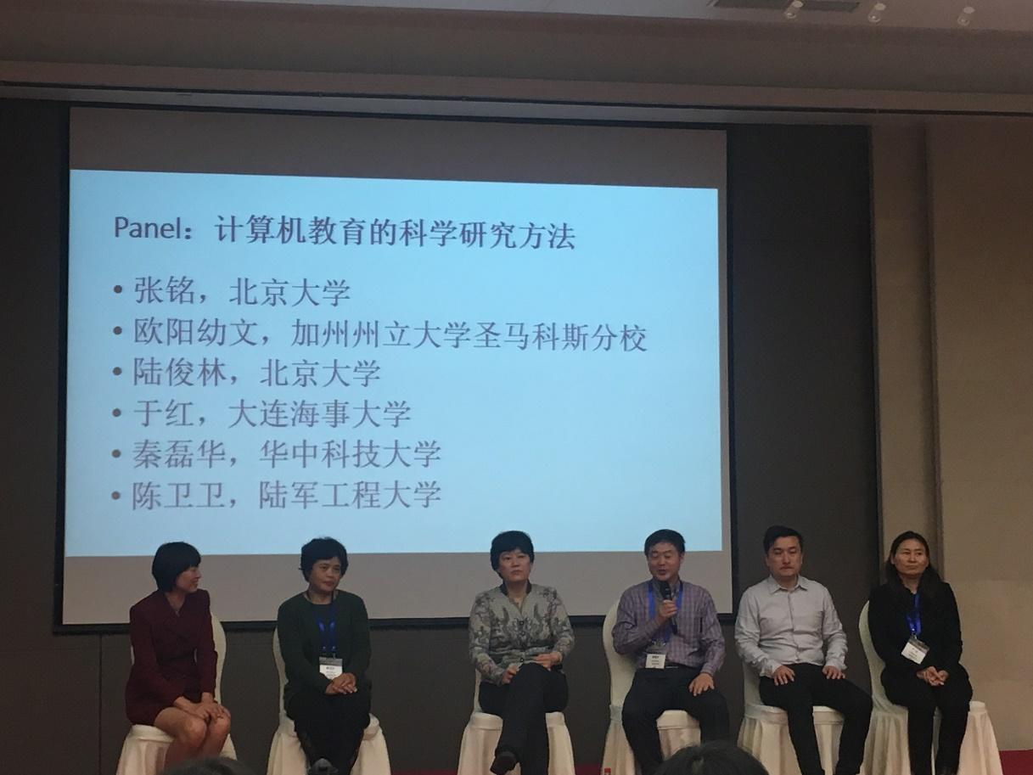

This workshop discussion was hosted by Prof. Ming Zhang (Peking University), the chair of ACM China SIGSE Chapter. Prof. Youwen Ouyang gave a keynote on designing and implementation of computer science education projects in the United States.

Ouyang is the dean of Computer Science department at California State University San Marcos. In the past 10 years she has been devoted to research on computer science education, and has hosted 7 US National Science Foundation projects on computer science education, with more than $ 6,000,000 research funding. In the panel, she shared her experience with education research and educational project application.

Prof. Ming Zhang introduced the new program F0701 sponsored by NSFC supporting Educational Information Science and Technology. Prof. Junlin Lu, Prof. Hong Yu, Prof. Leihua Qin and Prof. Weiwei Chen joined the panel after the above two keynotes.

The workshop attracted more than 100 attendees and the audience feedback was very positive.

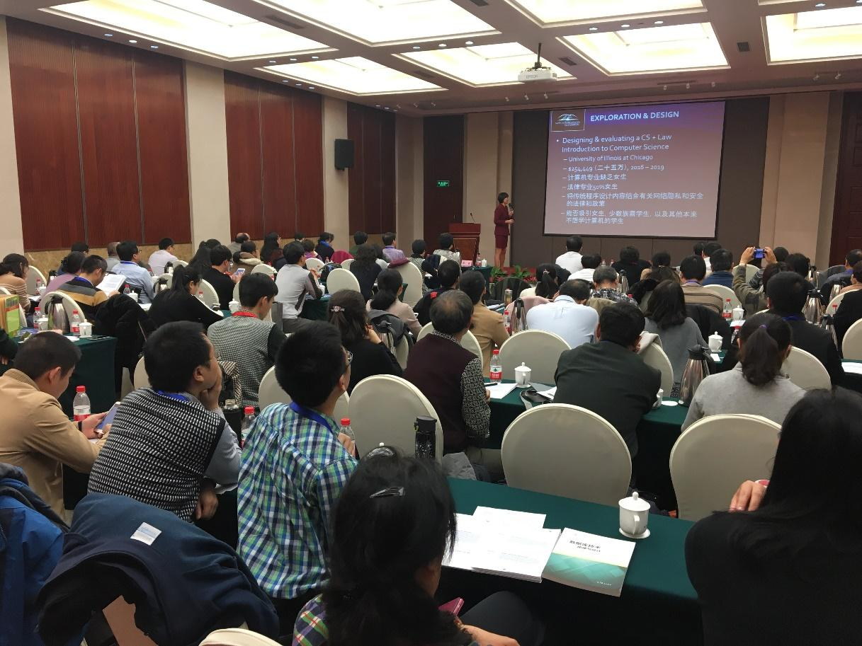

[Panel Discussion on IT2017, Hong Kong, December 12-14, 2017](https://china.acm.org/SIGCSE/IT2017.html)

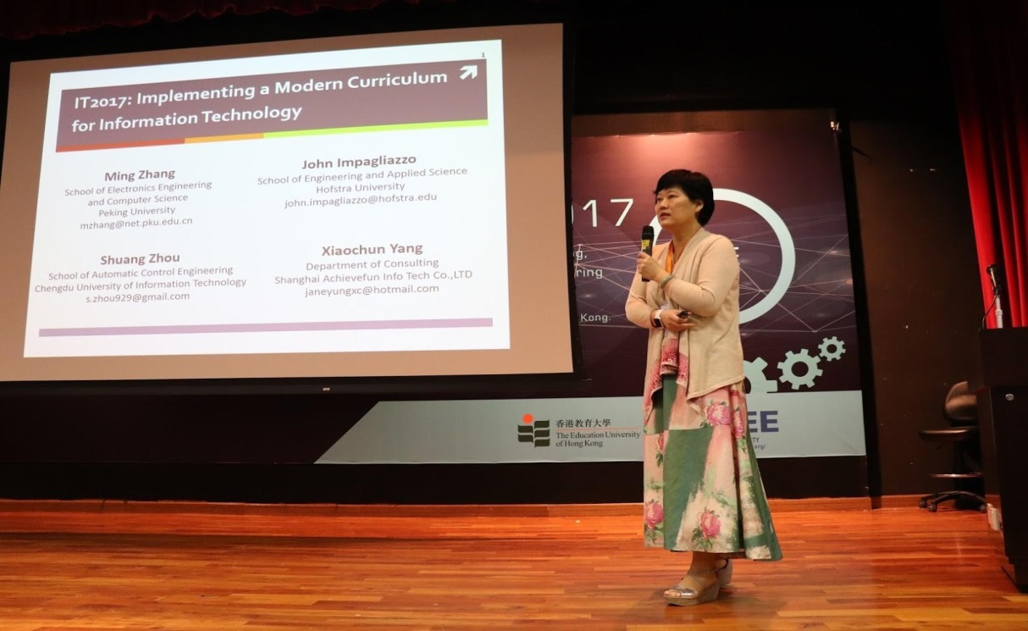

IEEE International Conference on Teaching, Assessment, and Learning for Engineering (TALE 2017) was held on 12-14 December 2017, in Hong Kong.

ACM China SIGSE Chapter held a panel discussion on Information Technology Curricula 2017 during the conference. This panel discussion was hosted by Prof. Ming Zhang (Peking University), the chair of ACM China SIGSE Chapter. In the panel discussion, Prof Ming Zhang, Prof. John Impagliazzo (Hofstra University, the U.S.A), Dr. Shuang Zhou (Chengdu University of Information Technology), and Ms. Xiaochun Yang (Shanghai Achievefun info Tech Co., LTD) provided an overview of the IT2017 Curricula Framework and shared experience and perspectives from China's point of view in implementing the IT2017 Curricular Framework. The attendees were impressed by the state-of-art IT programs in China.

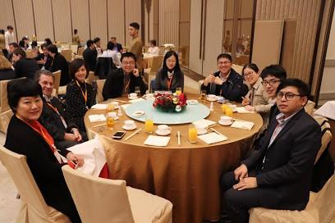

ACM China SIGCSE Chapter Held the Extended Council Meeting and the SIGCSE China Symposium at TURC, Shanghai, May 19-20, 201

The ACM China Turing Award Celebration Conference 2018 (TURC 2018) was held on May 19-20, 2018, in Shanghai, China. ACM China SIGCSE Chapter hosted the SIGCSE China symposium in this conference. An extended council meeting of ACM China SIGCSE Chapter, including 30 members, was held during the conference. This meeting was chaired by Professor Ming Zhang, the Chair of ACM China SIGCSE Chapter. At the meeting, the council members reported on progress in the last year and discussed the follow-up arrangements.

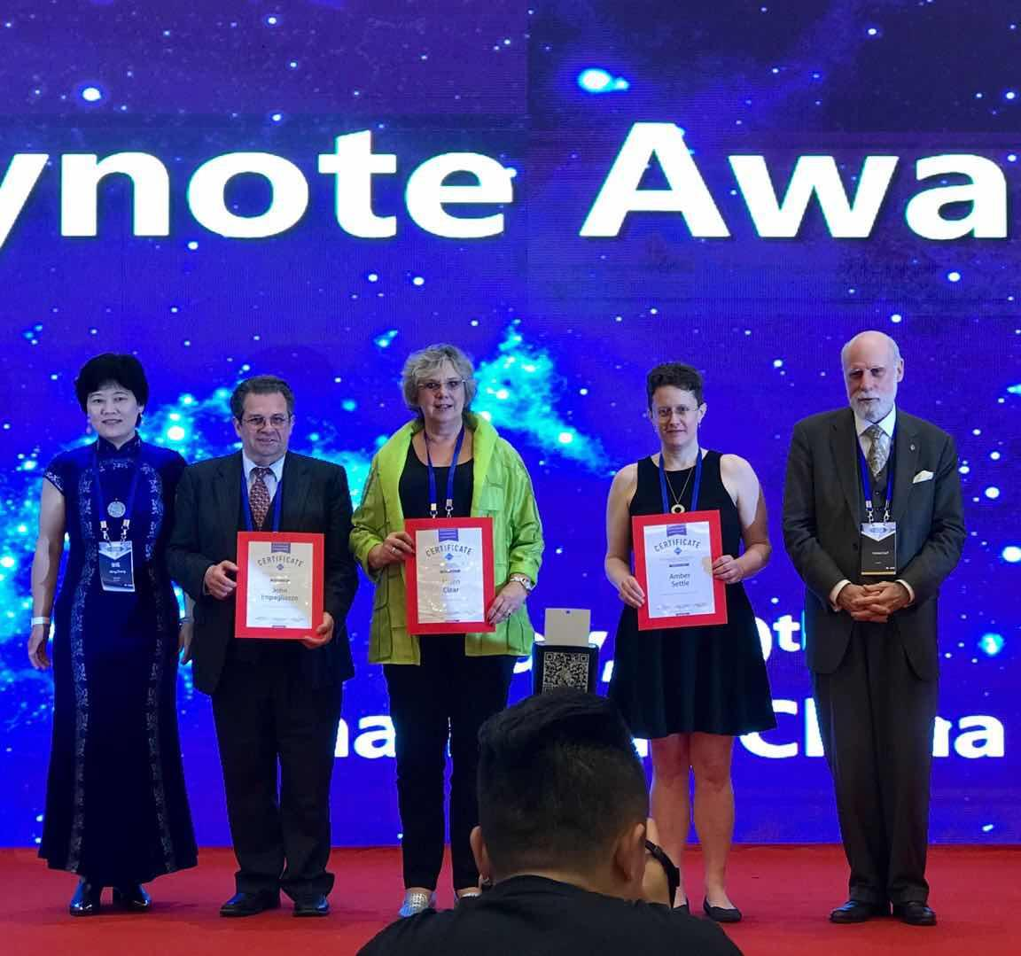

There were three keynote speeches at the 2018 SIGCSE China symposium. Professor Amber Settle, the ACM SIGCSE Chair, delivered a speech entitled “Fifty Years of SIGCSE: Now and Moving Forward.” Professor Alison Clear, the CC2020 Chair, delivered a speech entitled ACM/IEEE CC2020 Overview. Professor John Impagliazzo, delivered a speech entitled “ABET Accreditation.” The symposium organized two panels with the topics of Computer education research. 2018 SIGCSE China symposium accepted 17 papers and 11 posters. All papers were entered into the ACM Digital Library. Among them, two papers from the National University of Defense Technology China and Peking University won the Best Paper Awards. In addition, there were six student volunteers carrying a live of the meeting so that all the attendees could participate in this symposium and communicate with each other very well. Through the wonderful computer education research presentations and reports, a lot of computer science educators shared their new ideas for computing syllabi, laboratories, teaching, pedagogy and computer science education research. This SIGCSE China symposium promoted the communication and exchange of CS education in China and worldwide.

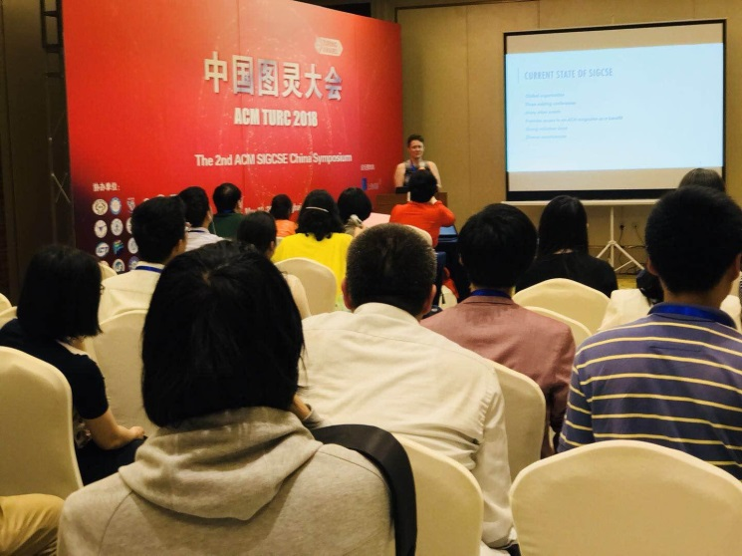

**Educational Efforts in Europe: Informatics for All**

ACM Education Board/Education Council representatives: Andrew McGettrick, Judith Gal-Ezer

The committee is now joint between ACM Europe, Informatics Europe and CEPIS (the Council of European Professional Informatics Societies). The membership is

Wendy Hall (chair)

ACM Europe: Judith Gal-Ezer, Andrew McGettrick

Informatics Europe:Enrico Nardelli, Michael Caspersen

CEPIS:Bob McLaughlin, Austeja Trinkunaite

A study had been undertaken by the *Committee on European Computing Education* (CECE) to determine the status of education in Europe in Digital Literacy and in Informatics; this activity was funded jointly by ACM Europe and Informatics Europe, each contributing $40k and was seen as a two-year study. The work began formally in April 2014 but the start was delayed. The final report *Informatics Education in Europe: Are we all in the same boat?* has now been completed and is published jointly by ACM and Informatics Europe.  See: <http://www.acm.org/binaries/content/assets/education/cecereport.pdf>

This study has been the basis of the work of the *Informatics for All Committee*.  A strategy document entitled *Informatics for All: The Strategy* had the enthusiastic support of all three member organizations; this has now been published and this was launched in Brussels on 15th March 2018 with EU representation present. (See europe.acm.org.) The EU has given the strategy their support. The main activity now is to roll out the ideas and have them adopted by all the member countries.  This activity will be less than straightforward and needs to be given careful consideration.

A long-term plan was to have ACM Europe and Informatics Europe involved in setting up a high-quality distinctive computing/informatics education conference in Europe; initial ambitions were replaced by an effort to have both organizations involved on the Organizing Committee of ITICSE, and initially ITICSE 2017. Now SIGCSE has recognized that ITICSE will have a prominent place as ACM’s European Computing Education conference and the conference organization has been adjusted to reflect this

During the year an election took place for the position of Chair.  Wendy was elected unanimously for this position.

**Curricular Efforts**

**CC2020**

Computing Curricula 2020 (CC2020) is a joint project launched by professional computing societies to examine the current state of curricular guidelines for academic programs granting degrees in computing and to provide a vision for the future of computing. The goal of the initiative is to produce a comprehensive report and interactive website that compares and contrasts these guidelines to situate and contextualize them in the landscape of computing education. Ultimately, the project strives to help programs to prepare graduates both academically and professionally to meet the challenges in the 2020s. The international project team represents organizations from academia, industry, and government.

The principal project sponsors are

* Association for Computing Machinery (ACM) and
* IEEE Computer Society (IEEE-CS)

with additional sponsorship from Association for Information Systems (AIS), and Association for Information Technology Professionals (AITP/EDSIG). Project collaborators include Special Interest Group for Computer Human Interaction (SIGCHI).

The project team consists of:

* a task force of approximately 34 members (currently 36) which includes
* a steering committee of up to 15 members (currently 13).

Members within this structure are representatives from the aforementioned organizations as well as from countries and regions around the world.

|  |  |  |  |  |  |  |  |
| --- | --- | --- | --- | --- | --- | --- | --- |
| **#** | **Member**  **Name** | **Country** | **Member Affiliation** | **Interest**  **Area** | **Email**  **Address** | **Steering Committee**  **Sponsor** | **Sub** |
| 1 | Alison  Clear  [Co-leader] | New  Zealand | ACM, IITPNZ, IEEE-CS | Computing Curricula | aclear@eit.ac.nz  alisonclear19@gmail.com | ACM |  |
| 2 | Allen  Parrish  [Co-leader] | United  States | IEEE-CS, ACM | Cybersecurity,  CSEC2017 | aparrish@usna.edu | IEEE-CS |  |
| 3 | Hala  Alrumaih | Saudi  Arabia | Al Imam Mohammad Ibn Saud Islamic University | Requirements Engineering, IT2017, IT, IS | haalrumaih@imamu.edu.sa  hala.alrumaih@gmail.com |  | C |
| 4 | Olga Bogoyavlenskaya | Russia | Petrozavodsk University Russian Computer Fed | Networks | olbgvl@cs.karelia.ru |  | C |
| 5 | Ernesto  Cuadros-Vargas | Peru | ACM, Latin America, CLEI, IEEE-CS | Computing Education, CS2013 | ecuadros@spc.org.pe | IEEE-CS | T |
| 6 | Adrienne Decker | United States | SIGCSE  University of Buffalo | Computing Education | Adrienne.Decker@rit.edu |  | R |
| 7 | Eric  Durant | United  States | Milwaukee School Engr,  IEEE-CS | Computer Engineering | durant@msoe.edu |  | C |
| 8 | Stephen  Frezza | United  States | Gannon Univ., IEEE-CS | Software Engineering | frezza001@gannon.edu | IEEE-CS | R |
| 9 | Marisa  Exter | United  States | Purdue University | Learning Design and Technology | mexter@purdue.edu |  |  |
| 10 | Steven  Gordon | United  States | ACM, Ohio Supercomp. Center | Big Data, Parallel Processing | sgordon@osc.edu |  | T |
| 11 | Eiji  Hayashiguchi | Japan | Info-tech Promotion Agency (IPA) | Government, IT Skill Sets | ei-haya@ipa.go.jp |  | C |
| 12 | John  Impagliazzo | United  States | Hofstra Univ., ACM, IEEE, AITP, IEEE-CS | IT2017,  CE2016, CC2005 | john.impagliazzo@hofstra.edu | ACM | C |
| 13 | Amey  Karkare | India | IIT Kanpur |  | karkare@cse.iitk.ac.in |  |  |
| 14 | Richard  Le Blanc | United  States | Seattle University | Software Engineering | leblanc@seattleu.edu |  | C |
| 15 | Paul  Leidig | United  States | Grand Valley State University |  | leidig@gvsu.edu |  | R |
| 16 | David  Lopez | Spain | Universitat Politècnica de Catalunya |  | david@ac.upc.edu |  |  |
| 17 | Barry  Lunt | United  States | Brigham Young Univ.,  SIGITE | IT2017, IT2008 CC2005 | luntb@byu.edu |  | C |
| 18 | Bruce  McMillin | United  States | Missouri U. Sci & Tech, IEEE-CS | Cybersecurity | ff@mst.edu |  | C |
| 19 | Tania  McVeety | United  States | IBM | Industry Perspective | tmcveety@us.ibm.com |  |  |
| 20 | Linda  Marshall | South Africa | University of Pretoria | Computing Curricula | lmarshall@cs.up.ac.za |  | T |
| 21 | Nancy  Mead | United  States | Carnegie Mellon University | Software Engineering Institute | nrm@sei.cmu.edu |  | C |
| 22 | Mirella  Moro | Brazil | Universidade Federal de Minas Gerais | Computer Science Education | mirella@dcc.ufmg.br |  |  |
| 23 | Arnold  Pears | Sweden | IEEE-CS,  ACM | CS2013 | arnold.pears@it.uu.se  pears@kth.se | IEEE-CS | C |
| 24 | Teresa  Pereira  Bernadino | Portugal | Instituto Politécnico de Viana Castelo | Robotics,  AI | tpereira@esce.ipvc.pt |  | C |
| 25 | Melinda  Reno | USA | Deloitte Consulting | Industry Perspective | mereno@deloitte.com |  |  |
| 26 | Ariel  Sabigue | Uruguay |  |  | asabigue@fing.edu.uy |  | C |
|  | Fermin  Sanchez | Spain | Universitat Politècnica de Catalunya |  | fermin@ac.upc.edu |  |  |
| 27 | Simon | Australia | University of Newcastle | Computing Education Research | simon@newcastle.edu.au |  | R |
| 28 | Shingo  Takada | Japan | Info. Proc. Society of Japan (IPSJ) | Japanese Education | michigan@doi.ics.keio.ac.jp | ACM | T |
| 29 | Heikki  Topi | United  States | Bentley Univ.,  ACM, AIS | MSIS, IS2010, Data Science, CC2005 | htopi@bentley.edu | AIS | C |
| 30 | Paul  Tymann | United  States | Rochester Inst. Tech, ACM, SIGCSE | Computing Education | ptt@cs.rit.edu |  | R |
| 31 | Gerrit  van der Veer | The  Netherlands | ACM, SIGCHI,  IFIP | User Experience,  IT2017 | Gerrit@acm.org | SIGCHI | T |
| 32 | Abhijat  Vichare | India | ACM India | Indian  Education | abhijatv@gmail.com | ACM | R |
| 33 | Barbara  Viola | United  States | Viotech Solutions,  AITP, ACM | IT2017, IT Industry Exec | bviola@viotechsolutions.com |  | C |
| 34 | Les  Waguespack | United  States | Bentley Univ., EdSig (AITP) | Computer Information Systems | lwaguespack@bentley.edu | EdSig | T |
| 35 | Pearl  Wang | United  States | George Mason U., CSAB, IEEE-CS | Parallel and Distributed Systems | pwang@cs.gmu.edu | IEEE-CS | R |
| 36 | Jane  Yung | China | Shanghai AchieveFun Info Tech Co., Ltd |  | janeyungxc@hotmail.com |  |  |
| 37 | Ming  Zhang | China | Peking Univ., ACM China, CCF | IT2017,  Chinese Comp. Education | mzhang_cs@pku.edu.cn | ACM | C |
| 38 | Stuart  Zweben | United  States | Ohio State Univ., ACM | SWE, ABET, Taulbee and NDC Studies | zweben.1@osu.edu |  | R |

The situation and context of degree granting computing programs are influenced by geography, varied conceptions of computing as discipline and as profession, and culture. Geographically and culturally, the project considers regions of the world by involving organizational representatives from a variety of countries. While currently published curricular guidelines (i.e., computer engineering, computer science, information systems, information technology, software engineering) and emerging curricular models (i.e., cybersecurity, data science) comprise CC2020’s central domain of interest, the CC2020’s deliverables are intended to inform the prospects for rethinking existing or shaping new computing degree programs and disciplines. Evolving cultural factors include approaches to learning computing, cultural dimensions of workplace practice, as well as societal implications.

The goal of the CC2020 task force is to produce a comprehensive resource to inform academia, industry, governments, and students, including:

* Comparative analysis of computing disciplines as represented in the curricular guidelines

* Integrative perspective of the disciplines within the computing landscape

* Shared and distinctive characteristics of discipline specific computing programs

* Contributions to a vision of the future of computing

The project intends to develop interactive tools for academia and industry to prototype models of knowledge and skill development to explore future curricular opportunities.

Meetings

During 2018 the Steering Committee met face to face before the SIGCSE symposium in Baltimore in March and also just prior to the Latin American Seminar in Lima Peru in October.  The Steering Committee also meet online every month and the subgroups also meet between 2 week (Tool Group) and 4 week (Writing Group) intervals. We also held a Working Group at the ITiCSE conference in Cyprus where eight people worked for four months online and then met f2f for five days and produced an extensive indepth report “Modelling Competencies for Computing Education Beyond 2020” on the development and modeling of competencies, the basis for the development of any computing curricular 2020 onwards.

Presentations and Seminars

Presentations, workshops and special sessions have been held throughout the year to gather information, direction and needs from the potential stakeholders.  This is important for getting our message out to the world and also collecting feedback on the direction and value of the deliverables. All these sessions have been well attended and feedback has been very positive. Funding for these came from the project and also many other sources.

For 2018

|  |  |
| --- | --- |
| Month | Place and Presenter |
| Feb | SC meeting Baltimore 19/20 Feb |
| Mar | EDUNINE Buenos Aires JI AC paper Eiji IPA Japan The ICD tool  International convention Tokyo panel Shingo |
| April | EDUCON Spain John & Arnold, round table & workshop |
| May | SIGCSE@TURC 2018 Ming John Alison Keynote and panel |
| June | ASEE workshop Steve & Barry Lunt, Marisa Exeter |
| July | ITiCSE Steve, Arnold & Gerrit |
| Aug | ACM Education Council meeting Portland, Alison and Allen |
| Sept |  |
| Oct | FIE Special session Allen Alison John,  CLEI Panel Ernesto,  SC meeting 20/21 Lima  Special Latin America Symposium 22 |
| Nov | EDSIG Con panel paper Les & Heikki |
| Dec | AIS San Fran panel Heikki & Les paper |

Progress

* Approximately 80 computing educators from all over South America attended the seminar in Lima and gave feedback on current progress and their needs for computing education for the future.
* A timeline was drawn up and the first draft of the CC2020 report will be available for the Steering Committee in February.  From there it will go out to the Task Force for comment, then during 2019 it will go out to the Task Force contact lists.
* The tool group who are developing the visualization tools have three prototypes ready for Steering Committee comment.
* A further face-to-face Steering Committee will be held in the first quarter of 2019 to assess the first draft of the report and the visualization tools.  (It was planned to coincide with the ACM CompEd conference in China however as of today that is now uncertain.)

**Joint Taskforce on Cybersecurity Education -** Completed

ACM Education Board/Education Council representatives: Beth Hawthorne and Scott Buck

* The publication date of "Curriculum Guidelines for Post-Secondary Degree Programs in Cybersecurity" is December 31, 2017 with ISBN: 978-1-4503-5278-9. About 25 hard copies were printed.
* Soft copies are available from <https://cybered.acm.org/> along with exemplars. The Guidelines were also published in the ACM DL.
* Officially unveiled at SIGCSE 2018 in Baltimore in February with a well-attended panel presentation. Also presented to the Ed Council meeting held at SIGCSE.
* Presented at other conferences during Summer 2018, including the Community College Cybersecurity Summit in Portland, OR.

**Data Science Taskforce**

ACM Education Board/Education Council representatives: Paul Leidig and Andrea Danyluk

Taskforce members:

Lillian (Boots) Cassel

Andrew McGettrick

David Culler

Hongzhi Wang

Christian Servin

Scott Buck

At the August 2017 ACM Education Council meeting, a task force was initiated to add to the broad, interdisciplinary conversation on data science, with an articulation of the role of computing discipline-specific contributions to this emerging field. Specifically, the task force is seeking to define what the computing/computational contributions are to this new field, in order to provide guidance for computer science or similar departments offering data science programs of study at the undergraduate level. The ACM Task Force on Data Science is in the process of finalizing the initial draft of a curricular report, which it will release for comment in Fall 2018

Accomplishments/activities for 2017-2018

* Held an in-person meeting prior to SIGCSE 2018 in Baltimore
* Held an in-person meeting prior to the August ACM Education Council meeting in Portland
* Held six taskforce conference calls
* Worked on a strawperson report.  We are writing the report using a data science competency framework.  Much of the material in this document leans heavily on the style of IT 2017. The motivation for this is to maintain consistency across a set of curricula documents produced by ACM.

**International Framework Taskforce**

ACM Education Board/Education Council representatives: Tracy Camp and Paul Tymann

While the ACM Education Council has global representatives, we do not believe this is the most effective way to ensure that the Board/Council is kept aware of computing education efforts in different countries.  For example, at a recent ACM Education Board meeting in London, briefings provided board members with valuable insights into European activities on Informatics for All, Cybersecurity, and Data Analytics. In order for the ACM Education Board/Council to establish itself as a global leader in computing education, it is vital that the Board/Council explore and implement formal ways of establishing connections with global computing societies.

This taskforce will develop a framework to formalize the ACM Education Board/Council’s connection with global organizations in order to improve the flow of global information to ACM Education Council members.  In our initial exploration, we will limit our work to Europe. The goal of this effort is to develop structures that will improve the flow of information between our European counterparts and to develop a framework that could be used in other countries. In order to achieve this goal, we suggest a small team from the ACM Education Board spend a day with education leaders in Europe. The purpose of the meeting would be to explore different ways to structure the connection between education leaders in Europe and the ACM Education Board/Council.

**SIGs and Other Organizations Reports**

**SIGCAS**

ACM Education Board/Education Council representative: Mikey Goldweber

There have been two primary foci with regard to educational activities:

1) The updated ACM Code of Ethics

2) Computing for Social Good

1) The updated Code of Ethics

Since a good number of the folks from COPE involved with the Code update are also active SIGCAS members, it was natural to work on activities together. Primarily this involved hosting workshops and information sessions at various conferences. In particular at this past SIGCSE Symposium on Computer Science Education (March '18 in Baltimore, MD), SIGCAS ran a half-day pre-conference "event" (Strategies for Integrating the Updated ACM Code of Ethics into the Computing Curriculum) and an evening COPE-focused event.

Informally, SIGCAS has been behind the effort to disseminate the announcement of the updated Code via its active Twitter feed and Facebook presence.

2) Computing for the Social Good

SIGCAS continues to be the primary SIG sponsor of the Computing for Social Good in Education (CSG-Ed) movement. This effort seeks to show educators how to evolve their current curriculum (programming projects, in-class examples, etc.) to highlight the importance of computing in solving the pressing problems of the day. All too often our projects and examples highlight games or billionaire-producing killer apps instead of how computing can assist in understanding and solving important social, environmental, or health-related problems (to name a few).

Also, at this past SIGCSE Symposium on Computer Science Education (March '18 in Baltimore, MD), the SIGCAS "sister track session" turned into a mini-workshop on the topic.

Finally, SIGCAS is now the primary SIG sponsor of two new workshops: COMPASS (Conference on Computing & Sustainable Societies) and Computing Within Limits. Both events, while not having specific "education" tracks or sessions, welcomed and accepted papers that had an education focus.

**SIGCHI**

ACM Education Board/Education Council representative: Gerrit van der Veer

SIGCHI:

* Currently counts between 3500 and 4000 members. About 30% of these consider themselves (at least part time) educators

Participated in the ACM – IEEE Task group that produced the Information Technology Curricula 2017 (IT2017) – <https://www.acm.org/binaries/content/assets/education/curricula-recommendations/it2017.pdf>

* Has over 25 “communities” among which there is one on HCI Education, counting 40 members: 32 participants & 8 affiliates. This community focuses on the past, present and future of HCI education, worldwide. <https://sigchi.org/communities/>
* Provides Student Travel Grants, a program that provides assistance for students with accepted contributions to attend SIGCHI (co)sponsored conferences. <https://sigchi.org/conferences/student-travel-grants/student-travel-grant/>
* Provides the Gary Marsden Student Development Fund, a special fund to provide assistance for students from the developing world to attend events, including HCI related conferences that are not sponsored by SIGCHI. <https://sigchi.org/get-involved/funding/gary-marsden-student-development-fund/>
* Supports Human Computer Interaction education for researchers and practitioners at all levels at CHI and our Specialized Conferences. Our SIGCHI sponsored conference, CHI, has an established track record of offering a wide variety of courses. <https://sigchi.org/conferences/courses/>. SIGCHI sponsored Specialized Conferences are also strongly encouraged to offer specialism-relevant courses at CHI and in their own conferences. SIGCHI sponsored conferences (both specialized and CHI) are encouraged to offer three kinds of courses:
  + foundational concepts for newcomers and those wanting to revisit and refresh their knowledge of HCI as an area of research and practice
  + specialized courses focused on depth in specific established and/or emerging areas and
  + technical skills and methodology courses which offer hands-on practical skill development.
* Provides access to a “SIGCHI Development Fund” as a benefit to all our members. A special funding initiative under this “SIGCHI Development Fund” is the sponsorship (partial) of Winter and Summer Schools in HCI. This supports our mission in HCI education beyond our regular workshops, conferences and meetings. <https://sigchi.org/2017/01/wintersummer-schools/>

**SIGCSE**

ACM Education Board/Education Council representative: Mark Weiss, Michelle Craig

The SIGCSE community continues to be very active and a strong partner with the Education Council. This year’s highlights:

SIGCSE Conferences

* The SIGCSE Technical Symposium was held on February 21-24, 2018 in Baltimore, MD, USA. There were 1,753 attendees, representing the largest attendance in the symposium’s history.
* The conference on Innovation and Technology in Computer Science Education (ITiCSE) was held on July 1-3, 2018 at Larnaca, Cyprus.  ITiCSE will be kept in the vicinity of Europe for the foreseeable future. SIGCSE has reached an agreement with ACM Europe and Informatics Europe to share governance of this conference through a steering committee with representation from the three organizations.
* The ACM Conference on International Computing Education Research (ICER), August 18-20, 2017 Tacoma, WA. There were 157 people in attendance, representing the largest attendance in the conference’s history.
* The SIGCSE Board approved a fourth major SIGCSE Conference: ACM Global Computing Education Conference (ACM COMPED). The first conference will take place in Chengdu, China, May 17-19, 2019. A steering committee for the conference has been created, and the steering committee will work in the next year both to support the organizers of the 2019 conference and to shape the direction that the conference will take in the next six years.

In-cooperation (with SIGCSE) status was approved for a number of conferences in FY18

* Koli Calling 2018
* Western Canadian Conference on Computing Education (WCCCE 2018)
* Workshop in Primary and Secondary Computing Education (WiPSCE 2018)
* Several Consortium for Computing Sciences in Colleges (CCSC) regional conferences including CCSC-MW ‘18, CCSC-SE’18, CCSC-NW’18, CCSC-EA’18, CCSC-RM’18, CCSC-MS’18, CCSC-NE’18, CCSC-SW’18, CCSC-CP’18, and CCSC-SC’18
* Australasian Computing Education Conference (ACE 2018)

Programs

* Twenty-seven applications were received in FY 2018 with six SIGCSE Special Projects funded for a total of $26,168.
* The Speaker’s Fund was used to support the dissemination of outstanding SIGCSE Symposium, ITiCSE, or ICER presentations to in-cooperation conferences.  Speakers were supported for one conference in FY 2018 for a total of $1,000.00.
* The Travel Grant Program supports first-time attendance at the SIGCSE Symposium for faculty and K-12 teachers by providing $500 for travel.  Nine awards were made to support attendance at the 2018 SIGCSE Technical Symposium, including a high school teacher and one recipient from Chile.
* The annual Doctoral Consortium was held in conjunction with the 2017 International Computing Education Research (ICER) Workshop in Tacoma Washington.  There were 19 participating doctoral students.
* Every other year the SIGCSE Board sponsors a New Educator’s Workshop where graduate students and new academics are provided with career information and mentorship. The New Educators Workshop took place on February 21, 2018 as a pre-symposium event before the 2018 Symposium.  The workshop was organized by Andrea Danyluk (Williams College) and Zachary Dodds (Harvey Mudd College). Forty one new educators attended the workshop. There were nine speakers, including the two organizers. Additionally, there were guests from the NSF and NCWIT. SIGCSE provided travel grants of $500 to each of nine attendees, six graduate students, one postdoc, one adjunct community-college professor, and one participant who could not attend in 2016 for funding reasons. Most of the remaining attendees were new faculty.
* The 2018 SIGCSE Symposium held thirty two three-hour workshops for professional development. In addition, the SIGCSE Symposium provided meeting space for thirteen events: Jumpstart Teaching Cybersecurity: C5 Instructional Modules Secure Scripting and Cybersecurity and Society; Computer Science Principles Providers and Teachers Forum; Integrating Cloud Computing into the Computer Science Curriculum; POSSE Roundup – Getting Started in an HFOSS Project; RESPECT'18: Research on Equity and Sustained Participation in Engineering, Computing, and Technology Conference; CS Education Infrastructure for All: Interoperability for Tools and Data Analytics; Professional Development Workshop for Teaching-Track Faculty; Strategies for Integrating the Updated ACM Code of Ethics into the Computing Curriculum; Machine Learning in the Classroom; Microsoft's Mixed Reality 250 Workshop; RPPforCS for Community Meeting; and NVIDIA Deep Learning Education Workshop.

**SIGGRAPH**

ACM Education Board/Education Council representative: Susan Reiser

The SIGGRAPH Education Committee works to support educators in computer graphics and interactive techniques. This encompasses technical, creative, applied and interdisciplinary studies at all post-secondary levels that intersect curricular areas of computer science, engineering, art, design and related disciplines. The Education Committee undertakes a broad range of projects and activities in support of the computer graphics and interactive techniques education community, such as developing curriculum guidelines, providing instructional resources, organizing SIGGRAPH conference-related activities and outreach. Ginger Alford chairs the ACM SIGGRAPH Education Committee and Erik Brunvand is the Education Liaison. Specifically, our charter is to manage, promote and encourage education content in all conference activities; and highlight and strengthen the education community that attends SIGGRAPH.

The 2017-2018 SIGGRAPH Education Committee had several subgroups involved in conference and year-round activities. For example, much of our recent work centered on preparing for the conference's Education Forum, which was held 08/13-14/2018 coincident with SIGGRAPH 2018 in Vancouver. Spearheaded by our conference liaison and committee chair, SIGGRAPH 2018's programming included panels on industry perspectives and forums on teaching VR and animation. To engage SIGGRAPH educators and recruit participation in our committee, we scheduled an open forum to discuss the conference and the committee's interesting work. The open forum was followed by a *Meet and Greet* during which we could get to know attendees. Throughout the conference, the committee staffed an Education Booth in a central location where conference participants could gather for informal conversation and to find out more about the Education Committee. Adjacent to the booth notable student work was continuously looped on a large screen display.

In an on-going effort to link SIGCSE and SIGGRAPH, we continued the SIGCSE Reprise during which outstanding and relevant-to-SIGGRAPH papers originally presented at SIGCSE 2018 were re-presented at SIGGRAPH 2018. Similarly, a couple of panel sessions and papers from SIGGRAPH 2017 were presented at SIGCSE 2018 in Baltimore, MD. *Groovy Graphics* debuted at SIGGRAPH 2018. It is a SIGGRAPH take on SIGCSE's popular and practical *Nifty Assignments*.

Over 16,500 people attended SIGGRAPH 2018 in Vancouver. The attendance was roughly the equivalent to that of SIGGRAPH 2017 which was held in LA, a location that typically draws more attendees. Educational opportunities at the conference included 21 courses and 10 studio workshops, 128 technical papers distributed throughout 38 paper sessions. Two highlights of the conference program were the keynote by Rob Bredow, Senior Vice President, Executive Creative Director, and Head of Lucasfilm company Industrial Light & Magic (ILM) and *VR@50*, a panel celebrating Ivan Sutherland's 1968 head-mounted 3D display system. Henry Fuchs moderated the all-star panel consisting of graphics pioneers Ivan Sutherland**,** Robert Sproull, Charles Seitz, Fred Brooks, and Quintin Foster, Jr.

The Electronic Theater program consisted of 25 short films including 5 student projects. (After the conference, a subset of the Electronic Theater program travels around the world to SIGGRAPH chapters, universities, and other conferences.) Additionally, SIGGRAPH 2018 included the Immersive Pavillion with Vrcade, a space for VR, AR, and MR games or experiences; the Village, a showcase for large-scale projects; and VR Theater, where Disney introduced their first VR Short, *Cycles*, an experimental film directed by Jeff Gipson.

Co-located with SIGGRAPH 2018 were several other conferences: ACM Symposium on Applied Perception, DigiPro 2018, Expressive 2018, Game UX & Cognitive Science Masterclass, and High-Performance Graphics 2018. Students at SIGGRAPH 2018 had a variety of ways to actively participate in the conference:

* be a student volunteer,
* submit a poster to the Student Research Competition,
* engage in the International Collegiate Virtual Reality Contest (IVRC),
* play a role in the Massive Collaborative Animation Project, and/or
* submit work to the Computer Animation Festival.

This year SIGGRAPH introduced special Sunday workshops on thought-provoking topics related to applications of computer graphics and interactive techniques. Participants applied to attend these sessions: *Truth in Images, Videos, and Graphics*; *Grand Challenges in Chronic Healthcare*; *Computer Graphics for Autonomous Driving Applications*; and a *Diversity and Inclusion Summit*.

The conference survey results are below although the response rate was poor. Of the 1258 participants who completed the survey:

OVERALL:

* 90% of Attendees answered Very Satisfied/Satisfied with the Conference & Exhibition
* 91% of Contributors answered Very Satisfied/Satisfied with the Conference & Exhibition
* 90% of Attendees and 92% of Contributors would likely recommend SIGGRAPH to a colleague

ATTENDEES:

* 55% 24-42 Years Old
* 71% Male
* 68% Work in U.S./Canada

EDUCATION REFERENCES:

* 13.9% of Attendees work in Education, and 28.9% of Contributors work in Education
* The majority of educators work in Higher Education (90% of Attendee Educators and 96% of Contributor Educators)

Which interest areas are most appealing to you? (INCLUDES ALL REGISTRATION TYPES, e.g. minority were educators)

        Attendee Contributor

Production & Animation 66.4% 51.5%

Research & Education 49.9% 71.2%

Fine Arts & Design 33.5% 25.2%

Gaming & Interactive 56.6% 52.8%

New Technologies 66.7% 67.5%

Multiple responses were allowed; therefore, total does not equal 100%

Immediately prior to the 2018 conference on 8/10/2018, the SIGGRAPH Education committee met for a full day to discuss activities and strategies. Specific topics include: our mission and goals, CGEMS, conference planning, SIGGRAPH Education website updates, outreach (global, K12, other organizations), and the ongoing curriculum study.

**SIGHPC**

ACM Education Board/Education Council representative: Steve Gordon

Over the past year, there have been a number of efforts by SIGHPC and the SIGHPC Education chapter to support computational science education. These have included the continuation of an international fellowship program, an online seminar series on computational science education, expanded participation in education chapter activities in both the US and Europe, and participation in several major conferences.

ACM SIGHPC/Intel Computational & Data Science Fellowships

This year SIGHPC and Intel awarded twelve fellowships in computational and data science aimed at increasing the diversity of students pursuing graduate degrees in these fields. The awards include a $15,000 stipend. Information on the awardees and fellowship program can be found at https://www.sighpc.org/for-your-career/computational-data-science-fellowships

Seminar Series

The SIGHPC Education Chapter continues to engage its members through an online education and training webinar series featuring speakers from both academic and non-academic institutions. A list of the webinars from this year can be found on the chapter website (http://sighpceducation.acm.org/) along with pointers to the YouTube videos of the sessions.

Expanded Participation in Education Activities

The SIGHPC Education Chapter merged its membership with an ad-hoc international committee on HPC education in March of 2018. The merger has expanded training and education efforts internationally, adding several new members from Europe, Australia, New Zealand and several other nations. The chapter has formed four working committees focusing on various aspects of promoting education and training in computational science. Descriptions of the standing committees and their efforts can be found at https://sighpceducation.acm.org/committees.html.

Participation in Major Conferences

The SIGHPC Education chapter participated in several major conference over the past year. This includes a workshop at ISC17, a special session on education at the SIGCSE meeting, and a workshop and birds-of-a-feather session at the SC17 conference.

**SIGITE**

ACM Education Board/Education Council representative: Mihaela Sabin

SIGITE continues to be financially stable and maintain same level of membership as last year (322 members). Membership communications include listserv exchanges, an organization web site, a newsletter and annual conferences.

The 18th SIGITE and the 6th Research in IT conferences (RIIT) took place October 4-7, 2017 in Rochester NY, hosted by the Rochester Institute of Technology. Participation was strong: 126 attendees and 94 submissions, 69 of which were paper submissions: 58 paper submissions for SIGITE (23 accepted, 39% acceptance rate), and 11 paper submissions for RIIT (6 accepted, 54% acceptance rate). Conference post-surveys indicated that 90% of responding participants rated key conference aspects as very good or excellent.

The 19th SIGITE Conference is scheduled October 3–6 in Fort Lauderdale, hosted by Broward College. There were 101 submissions, of which 60 were paper submissions (24 accepted, 40% acceptance rate). Given low participation in the RIIT conference, starting 2018 we will have only the SIGITE conference, which will include an IT Research track.

SIGITE elections were held in Spring 2018. Election results for 2018 - 2021 are:

* Barry Lunt, Brigham Young University, Chair
* Ray Trygstad, Illinois Institute of Technology, Vice-Chair
* Karen Patten, University of South Carolina, Secretary and Treasurer

**SIGPLAN**

ACM Education Board/Education Council representative: Susan Eisenbach

Distinguished Educator’s Award:

This award is given by ACM SIGPLAN to recognize the value and degree of services to the Programming Languages Community. The award recognizes contributions to ACM SIGPLAN, its conferences, publications, or its local activities. The award includes a prize of $2,500. http://www.sigplan.org/Awards/Educator/.

Empirical Evaluation Guidelines

The programming languages research community often develops ideas whose worth is evaluated empirically. Compiler optimizations, static and dynamic analyses, program synthesizers, testing tools, memory management algorithms, new language features, and other research developments each depend on some empirical evidence to demonstrate their effectiveness. This reality raises some important questions:

* What kind of empirical evidence yields the most reliable conclusions?
* What are the best practices for putting together an empirical evaluation in PL research?
* Do PL research papers published in top venues always follow these best practices?

To answer these questions, in August of 2017 the SIGPLAN Executive Committee formed the ad hoc committee on Programming Language Research Empirical Evaluations. Since its formation, the committee has examined the literature to identify common forms of empirical evaluation applied to the various kinds of PL research. This examination has identified inadequacies that regularly arise, even in papers published recently in highly regarded venues, including PLDI, POPL, ASPLOS, OOPSLA, and ICFP. The committee has organized and categorized its findings, producing a 1-page best-practices checklist.

(http://www.sigplan.org/Resources/EmpiricalEvaluation/)

SIGPLAN runs a workshop called PLMW (Programming Languages Mentoring Workshop) at its four flagship conferences. This workshop:

* Aims to encourage graduate students and senior undergraduates to pursue careers in programming language research.
* Provides a blend of cutting-edge research talks with mentoring for academic careers.

SIGPLAN provides much of the cost of both PLMW and the flagship conference for attendees.

**Code.org**

ACM Education Board/Education Council representative: Pat Yongpradit

Code.org is the lead organization broadening participation in K–12 computer science. Code.org was one of the five organizations, including the ACM, that served on the steering committee for the K–12 Computer Science Framework.

* Reached 30M students and almost 1M teachers on its platform. 30% of all U.S. students now have an account on Code.org
* Grew our Regional Partner network to 60 organizations and successfully prepared a cumulative 80,000 new CS teachers.
* Published studies showing that (1) Code.org program in high schools causes an estimated 5x increase in participation and success in AP computer science, with the greatest gains among young women and underrepresented minorities (2) increased use of Code.org in elementary school classrooms of resourceful teachers is directly correlated to improved scores in math, reading, and science.
* Helped 33 states adopt 68 policies to expand access in computer science
* Grew the Hour of Code campaign to "600M served"
* Particular to the K-12 CS Framework: States, organizations, and institutions of higher education have used the Framework to guide the development of state plans, standards, curriculum, and teacher preparation programs

**Committee for Computing Education in Community Colleges (CCECC)**

ACM Education Board/Education Council representative: Cara Tang

CCECC GLOBAL MISSION: ccecc.acm.org/about

The ACM CCECC serves and supports community and technical college educators in all aspects of computing education.

CCECC PURPOSE: ccecc.acm.org/about

The ACM Committee for Computing Education in Community Colleges (CCECC) is a standing

committee of the ACM Education Board concerned with computing education at associate degree granting colleges in the United States and similar post-secondary institutions throughout the world. The Committee engages in curriculum and assessment development, community building, as well as advises on public policy and advocacy in service to this sector of higher education.

CCECC BRIEF HISTORY: <http://ccecc.acm.org/history>

CCECC CHARTER: <http://ccecc.acm.org/about/charter>

CCECC MEMBERSHIP: http://ccecc.acm.org/about/members

Members

* Cara Tang, PhD, CCECC Chair; Department Chair and Faculty, Portland Community College, OR
* Cindy Tucker, CCECC Vice-Chair; Professor, Bluegrass Community and Technical College

Emeriti Members

* Dr. Elizabeth K. Hawthorne (former chair)
* Mr. Robert Campbell (former chair)
* Dr. Karl Klee (former chair)
* Dr. John Impagliazzo (founder)
* Dr. Joyce Currie Little (founder)
* Dr. Dick Austing (founder)

The CCECC achieved the following milestones in FY18 (July 1, 2017 – June 30, 2018):

* Disseminated Computer Science Curricular Guidance for Associate-Degree Transfer

Programs with Infused Cybersecurity (CSTransfer2017):

* Available at ccecc.acm.org/CSTransfer2017
* Based on the ACM CS2013 guidelines, with cybersecurity infused
* Panel session at Community College Cybersecurity Summit (3CS), June 2017
* Paper presentation at SIGCSE, Feb 2018 (recording available on CCECC YouTube Channel)
* Presentation at Tri-State Women in Computing Celebration, Feb 2018
* Presentation at Fast Track to Success, April 2018
* Panel at Cyber Education Workshop, April 2018
* Contributed Community College Exemplars to CSEC2017:
* Curriculum exemplar: Portland Community College, OR
* 4-Course Exemplar: El Paso Community College, TX
* Course Exemplar: Cosumnes River College, CA
* Launched CSEC2Y project to develop curriculum guidelines for 2-year programs in cybersecurity:
* Based on ACM’s CSEC2017 curriculum guidelines
* Task group made up of 10 community college educators representing a variety of
* expertise areas within cybersecurity, and geographic distribution across the U.S.
* Advisory group of 10 experts including representation from industry, government,
* 4-year schools, cybersecurity organizations, and the CSEC2017 task group
* Formed task group in preparation for beginning IT Transfer project to develop guidance

for IT transfer programs based on IT2017.

* Contributed to efforts on Broadening Participation in Computing:
* Participated in October 2017 CS Education Summit: Addressing the Challenges of Increasing Interest in Computing at the Undergraduate Level through Institutional Transformation
* Participated in January 2018 workshop on Authentic Inclusion of Community Colleges in National Efforts to Broaden Participation in Computing
* Supported ACM Education Policy Committee’s Community College Transfer Pathways Report:
* Identified schools for case studies
* Reviewed draft report and offered feedback
* Added members from Colombia, Brazil, and Greece to our international advisory group (ccecc.acm.org/about/advisors)

• At SIGITE 2017:

* Hosted a community college reception for the third year in a row
* Supported the conference with a table, engaging with attendees on community college computing issues and distributing curricular guidelines

• At SIGCSE 2018:

* Hosted an evening dessert reception for community college educators and friends

for the third year in a row, with three sponsors, and a drawing for tech prizes

* Hosted a breakfast for community college educators and friends for the first time,

facilitating table discussion on issues important to community college educators

* Engaged with the community, spreading awareness of CSTransfer2017 guidelines

through a paper presentation

* Staffed a booth in the exhibit hall to facilitate interactions with the community
* Supported connections with the community through social media, including Twitter, Facebook, and YouTube:
* Utilized Facebook LIVE to broadcast CCECC presentations and informal presence at

SIGCSE and 3CS

* Created an ACM CCECC YouTube Channel for posting presentations and other relevant videos, starting with our SIGCSE 2018 paper presentation
* Recruited one new Committee member (joined July 1, 2018): Melissa Stange, Lord Fairfax Community College, VA
* Maintained the website (ccecc.acm.org) with updated committee publications and conference events
* Maintained CCECC educator database with over 5,000 email contacts of two-year college computing educators
* Continued serving on the ACM Education Council – (www.acm.org/education/educationcouncil-and-education-board)
* Continued serving on the ACM-W Council – women.acm.org
* Shared booth space at SIGCSE 2018
* Continued to support increasing community college participation in ACM-W work:
* Continued to use our educator database to generate lists of community college faculty located near ACM Women in Computing (WIC) celebrations, and provide customized lists to each U.S. WIC coordinator to facilitate personalized invitations to the events. In 2017-2018, lists were generated for 11 WICs across the U.S.
* Serving on the newly formed ACM Task Force for Data Science to develop undergraduate curricular guidelines for computing Data Science programs
* Participated in the American Statistical Association’s Two-Year College Data Science Summit, May 2018, representing the computing discipline and ACM.
* Engaged in a variety of advocacy and outreach efforts on behalf of computing education in the community college sector, including the following conferences:
  + Community College Cybersecurity Summit (3CS) 2017 (June)
  + SIGITE 2017 (October)
  + SIGCSE 2018 (February),
  + Fast Track to Success (April 2018)
  + Cybersecurity Education Workshop (April 2018)
  + NCWIT Summit (May 2018)
* Ongoing communications with colleagues via the featured, quarterly Community College Corner column in *ACM Inroads* – columns available in the ACM Digital Library as well as from https://ccecc.acm.org/literature/publications
* Contributed an article on SIGCSE and two-year schools to the Inroads special section celebrating 50 years of SIGCSE
* Ongoing dissemination and outreach activities, including periodic mailings and email messages to contacts in the CCECC educator database, website enhancements, articles, conference sessions, and exchanges and collaborations with colleagues
* Ongoing support for the ACM Education Council and Education Board goals and objectives

**CSTA**

ACM Education Board/Education Council representatives: Jake Baskin CSTA CEO, Jane Prey, Bobby Schnabel

2017-18 was a year of transition and renewal for CSTA, with a new leadership team, new organizational priorities and a new membership program designed to build out a sustainable future for the organization.

Key highlights from July 2017 - June 2018

* New leadership team of Jake Baskin as Executive Director and Michelle Page as COO came on board in early 2018.
* The 2017 CSTA standards were released in July; since then 5 states have adopted them outright, and every state that has written CS standards since the release has used our standards as a starting point.
* CSTA began its first full fiscal year as its own 501c3 non-profit organization.
* The largest CSTA conference ever was held in July 2017 in Baltimore, MD.

**Education Policy Committee**

All existing projects listed below have been completed.

**Computer Science for All Steering Committee & Board**

ACM, through the Education Policy Committee, participated in the steering committee for the effort to enable expanded access to computer science and support for computer science teachers. The Computer Science for All Consortium eventually became its own standalone organization: CSforALL, and EPC Chair, Jeff Forbes, became a board member.

**Computing Jobs & Education Pathways Policy Research Project**

The EPC, in partnership with the Computer & Information Science & Engineering Directorate of the National Science Foundation and the Institute for Research on Innovation and Science (IRIS) at the University of Michigan, proposed to partner with LinkedIn to conduct a study of computing jobs, including their relation to computing education. Key questions this project would examine include:

* How are computing jobs distributed across industry sectors?
* Which types of computing jobs are most common in various industry sectors?
* What are the educational backgrounds of people holding (various sorts of) computing jobs and do their backgrounds vary depending on industry sector?
* What types of jobs do people with (various types of) computing education and degrees hold at various stages of their careers?

This proposal was submitted to LinkedIn and was declined in October 2017. Since we submitted unsuccessful proposals in 2015 and 2016 as well, this project is on hold until further notice.

**CSforALL Commitment**

At the CS for All Summit on October 17, 2017, Jeff Forbes announced that ACM is launching a campaign encouraging their US professional members to support CSforALL by volunteering their technical expertise to support K-12 CS education partners including the Computer Science Teachers Association (CSTA), CSforALLTeachers, and TEALS. Members were encouraged via email and social media. TEALS is now tracking which of its new volunteers are ACM members.

**Community College Transfer Pathways Report**

The EPC commissioned a project to review, research, and gather data and information on how current education systems serve students transitioning from 2-year community colleges to computing-related degree programs at 4-year colleges and universities. The goal was to determine what policies, practices, and structures can states adopt to increase the number of 2-year college students who successfully transfer to and complete a bachelor’s degree in computer science and computing-related fields, with particular attention to students from underrepresented groups.

Lou Ann Lyon from ETR Associates led the development of the report with the following sections:

* Workforce landscape for jobs and careers for computing degree
* Changing and new roles of community colleges
* Role of transfer articulation agreements and best practices
* Case studies from 5 states:
* New Jersey: Kean University & Local Community Colleges
* Kentucky: Bluegrass Community & Technical College
* Oregon: Western Oregon University & two local Community Colleges
* Hawaii: University of Hawaii & Leeward Community College
* California: Cal State University, Monterey Bay & Hartnell College

**Other Items:**

**Education Board Rotation and Education Council Rotation**

**Education Board and Council Rotation:** The Education Board and Council rotation process was delayed this year due to the ACM executive board elections and the need for the new president to understand our process.

Impact:

* The Education Council was re-named as the Education Advisory Committee.
* The appointment of the Education Board co-chairs was delayed. This delay caused a major delay in the writing and publishing of the 2018 Annual Report.
* The appointment and re-appointment of Board and Council/Committee members was also delayed.

The **ACM Education Board and Council rosters at the end of FY 2018** were as follows (* denotes members whose terms ended at the end of FY 18 and Advisors rotating off). **Education Board:**

|  |  |
| --- | --- |
| **Co-Chair** | Mehran Sahami |
| **Co-Chair** | Jane C. Prey |
| **Vice Chair** | Elizabeth K. Hawthorne |
| **Past Chair** | Andrew McGettrick |
| **Members** | Valerie Barr* |
|  | Scott Buck |
|  | Alison Derbenwick Miller |
|  | Chris Stephenson |
|  | Tracy Camp |
|  | Paul Tymann |
|  |  |
| **ACM Headquarters** | Yan Timanovsky |
| **Ex-Officio** | Jake Baskin (CSTA Executive Director) |

**Education Council:**

**Members**

|  |  |
| --- | --- |
| Michael Caspersen | ACM Europe; It-vest - networking universities |
| Michelle Craig | SIGCSE; University of Toronto |
| Janice E. Cuny | NSF |
| Andrea Danyluk | Liberal Arts/Small Schools; Data Science Co-Chair; Williams College |
| Susan Eisenbach | SIGPLAN; Imperial College London |
| Jeff Forbes | Education Policy Committee; Duke University |
| Mikey Goldweber | SIGCAS; Xavier University |
| Steve Gordon | SIGHPC |
| Shuchi Grover | STEM/CS Ed Researcher/Consultant/Trainer |
| Chris Hundhausen | TOCE Editor |
| Andrew J. Ko | University of Washington |
| Paul Leidig | CSAB rep; Grand Valley State University; Data Science Co-Chair |
| Jim Leone | CSAB rep; RIT |
| Mirella M. Moro* | Brazil;  Universidade Federal de Minas Gerais - UFMG |
| Brianna Morrison | University of Omaha |
| Peter Norvig* | Google |
| Andrew Peterson | University of Toronto |
| Susan Reiser | SIGGRAPH; University of North Carolina at Asheville |
| Mihaela Sabin | SIGITE, University of New Hampshire |
| Deborah Seehorn* | CSTA Volunteer Representative |
| Ben Shapiro* | ATLAS Institute; University of Colorado Boulder |
| Cara Tang | CCECC Chair; Portland Community College |
| Jodi L. Tims | ACM-W; Baldwin Wallace University |
| Gerrit Van der Veer | SIGCHI rep; Vrije Universiteit Amsterdam |
| R. Venky | ACM India; Tata Consultancy |
| Mark Allen Weiss | SIGCSE rep; Florida International University |
| Pat Yongpradit | Code.org |
| Ming Zhang | ACM China; Peking University |
| Stu Zweben | NDC Study; The Ohio State University (Emeritus) |
| Yan Timanovsky | Headquarters Liaison |
| **Advisors** |  |
| Owen Astrachan* | AP CS Principles; Duke University |
| Daniel D. Garcia* | AP CS Principles; University of California - Berkeley |
| Alison Clear | CC2020; (SIGCSE); Eastern Institute of Technology |
| Eric S. Roberts | Booming Enrollments/Building Capacity Taskforce; Stanford University |
| Heikki Topi* | AIS liaison; IS curricula; Data Science curricula; Bentley University |
|  |  |
|  |  |

**Section Two – Future Plans**

**Priorities for FY2018 - 2019**

During the previous FY much progress was made on a number of fronts. New members of the Education Board and Education Advisory Committee are now in place. Our Council meeting July 31-August 1 in Portland OR also generated a list of new ideas for FY2018.

**New Ideas for FY2018 – 2019 include:**

Global Awareness Taskforce

International Education Framework

Taskforce on Ethics and Social Responsibility

Transitioning the EngageCSEdu repository to an ACM e-journal

**Plans for Future Work**

**CC2020**:

The CC2020 committee has been meeting monthly and has made great progress.

Current plans - 2019 Presentations and Information Gathering

* SIGCSE, Minneapolis, February:
  + A pre-conference event on visualization has been accepted
  + A Special Session on what will help mainly U.S.-based computing educators, and
  + A Birds of a Feather session to chat to SIGCSE participants.
* ACM CompEd, May, Chengdu, China:
  + A Visualisation Working Group has been accepted, and
  + A panel to determine what help Chinese educators need.
* ITiCSE, July, Aberdeen, A Visualisation Work Group has been accepted. (Different from the one at CompEd)
* FIE October: TBD
* COMPUTE India, October:
  + A face-to-face Steering Committee meeting, and
  + A seminar for Indian educators (as we did for Latin America and China)
  + We will also be finalising the distribution of the Strawman report and visualization tools

The Steering committee are committed to ensuring the project stays on target and gathers information from all stakeholders, the first draft of the report is being assembled now for distribution in February.

**Committee for Computing Education in Community Colleges (CCECC)**

The CCECC plans to pursue the following activities in FY19 (July 1, 2018 – June 30, 2019):

* Continue to disseminate and collect program examples for CSTransfer2017 guidelines
* Continue the CSEC2Y project developing associate-degree curricular guidance in Cybersecurity based on CSEC2017. Tentative timeline:
* Feb 2019: Release StrawDog draft for public review and comment
* July 2019: Release IronDog draft for public review and comment
* Dec 2019: Final version available
* Begin the IT Transfer project developing guidance for IT transfer programs based on IT2017
* Update and grow the database of community college computing educators
* Continue to seek international perspectives to the Committee’s work
* Continue recruiting and mentoring new CCECC members
* Continue engaging with the community through social media channels, and utilizing the new CCECC YouTube channel
* Ongoing maintenance of committee website ccecc.acm.org
* Continue serving on the ACM Education Council (Cara Tang)
* Continue supporting the ACM Education Policy Committee in community college-related work
* Continue serving on the ACM-W Council (Cindy Tucker) and collaborating with ACM-W
* Continue serving on task force for Data Science Curriculum Guidelines (Christian Servin)
* Continue collaborating with CSTA
* Continue communications with colleagues via the quarterly Community College Corner column in ACM Inroads
* Continue a variety of advocacy and outreach efforts on behalf of computing education in the community college sector, such as various conferences, articles, meetings, and workshops
* Ongoing community-building, outreach, and dissemination activities, including conference sessions, periodic email messages to contacts in the CCECC educator database, social media engagement, website enhancements, articles, and exchanges and collaborations with colleagues.
* Ongoing support for the ACM Education Council and Education Board goals and objectives.

**Code.org**

At a high level, Code.org will continue to offer curriculum, tools, and professional development at no cost, promote computer science education awareness, develop a network of regional partners, and engage in federal and state level policy and implementation.

* We are launching a theme for Hour of Code and CSEdWeek, with a focus on creativity
* We continue growing on all vectors in the U.S. and beyond, whether usage of Code.org, preparing of new teachers, or policy and advocacy growth, including global expansion, via a network of international partners
* Particular to the K-12 CS Framework: Many countries are using the Framework to inform their own country-wide initiatives such as a national vision, standards, and curricula. Code.org will continue to promote and provide technical assistance to states and countries interested in using the Framework. In 2019, we are considering a convening of stakeholders across K-16 educators + tech industry, to talk about the future of the K-16 pathway in CS education -- because as changes/refreshes are considered for the K12 CS Framework, the CSTA Standards, various state standards, the College Board AP CS exams, or higher-ed courses to handle capacity issues and the industry's hiring needs, all of these things are interrelated and at the scale of growth of CSEd it is worthwhile to plan them in coordination across all the stakeholders

**CSTA**

* We launched CSTA+, a new membership tier that delivers even more benefits to members and begins to build a sustainable revenue stream for the organization
* CSTA secured a $2M commitment over three years from Microsoft to help build the financial stability of the organization as we expand our staff and programming
* Hosted 69 chapter leaders from 45 chapters at our annual Chapter Leaders Summit, where every participant said they would recommend the sessions to a peer
* The 2018 CSTA annual conference in Omaha, NE was the first ever CSTA conference to sell out and was the most profitable conference in CSTA history (by an order of magnitude)
* We partnered with Code.org to host over 100 state policy makers from across the US at the Code.org / CSTA state policy forum in Denver and released the 2018 State of CS Education policy report
* As we launch our focus on local chapters, we will roll out annual grants to enable chapters to implement local programming that meets the needs of their membership.
* A small set of these grants will focus on supporting large scale PD events, allowing local chapters to bring national PD providers into their state and work with local departments of education to provide a broad range of PD options
* We’re preparing for the 20th anniversary of the CSTA conference in Phoenix in July 2019. We are anticipating that this will be the largest CSTA conference ever
* Launching in October 2018, we will develop Computer Science Educator Standards in partnership with ISTE. These standards will be focused on the skills and content that computer science teachers should have, and will help guide pre-service teacher preparation and professional learning program development
* We will host CSTA’s first CS Ed Week Kick Off event in Chicago during CS Ed Week 2018
* We’re working to continually add value to our paid membership package to provide a compelling value proposition to our membership
* Bringing in at least $4M in additional commitments through 2021 to support all of the above work

**Data Science Taskforce**:

Planned activities/strategies for 2018-2019

* Submitted proposals/papers to three conferences to begin open conversations
* Special Session at ACM SIGCSE 2019
* Short paper at EAAI 2019
* Panel proposal at JSM 2019
* Planned submission for SIGCE Global
* Expand taskforce with additional members from China, Brazil, and the UK
* Expand taskforce with representation from statistics and/or mathematics disciplines
* Publish a strawperson report with a call for public comments
* Release draft report including a summary of Data Science curricular efforts to date, results of an ACM academic and industry surveys on data science, as well as the initial articulation of computing competencies.

**Educational efforts in China**

* ACM SIGCSE Global Computing Education Conference 2019, Chengdu, May 14-19, 2019
* Enlarged Council Meeting and the SIGCSE China Symposium at TURC 2019, Chengdu, May 18-19, 2019
* ACM/IEEE CC2020 Meeting, Chengdu, May 14-16, 2019

**Educational Efforts in Europe: Informatics for All**

The immediate and considerable challenge now facing the *Informatics for All Coalition* is to make progress towards the implementation of the strategy. This involves making changes to the arrangements for the teaching of Informatics in almost all the countries of Europe. So three initial tentative steps are being taken:

* At the Informatics Europe annual conference being held this year in Gothenburg, Sweden on 8th to 10th October there is to be a discussion on the strategy with the Deans of Informatics. At this meeting advice will be sought on the way ahead. At the conference, representatives from the EU will be present and the opportunity will be taken to discuss the matter with them (including the possibility of piggy-backing the EU Digital Education Action Plan)
* Dialogue has been opened with PISA, the Programme of International Student Assessment, based in OECD (the Organisation for Economic Cooperation and Development). An initial exercise has involved passing comment on their mathematics framework that now boasts considerable elements of computational thinking
* A Workshop on Informatics for All is being organized for February 2019 probably in Brussels. The current plan is for around 60 attendees, these to include the Informatics for All Committee (including Adviser Bobby Schnabel), teachers and representatives of teachers’ organizations, industry, academics as well as other interested parties. Attendance will be by invitation (at least initially) and attendees are being asked to fund their own travel.

**Global Awareness Taskforce**

Andrew Petersen (Chair)

Alison Clear

Michelle Craig

Shuchi Grover

Mirella Moro

This taskforce is the result of discussions at the 2018 Education Council Meeting that raised concerns about the ability of international members to participate in discussions about education due to differences in terminology and context. For example, the term “college” may refer to different types of institutions in various parts of the world.

* Consult with experts in the language industry to identify common internationalization issues and with members of the ACM computing education community to identify problematic domain terminology
* Author a short guide for authors writing about computing education issues that identifies and defines problematic terms and provides guidelines for internationalizing a document. This guide may accompany an online tool that accepts a text document and flags terms that have been previously identified as potentially having different meanings in various parts of the world
* Author a guide for conference and meeting organizers that identifies issues to consider to enable international participation

**Learning at Scale**

Planning for the 2019 conference has gotten into full swing.  The Program Chairs for Learning @ Scale 2019 are in the process of being finalized.  The conference venue is also being determined, but is likely to be held at UCSD. The exact dates for the conference will be determined once the venue is established.

**NDC Survey**

We plan to conduct the 2018 NDC Study and publish its results according to the same schedule used in 2017-18. We also will contract with NSC for one year’s data about computer science enrollments and retention, will analyze the data obtained and will publish our findings if they appear to be worth publishing. Based on our analysis, we will determine how and if NSC data can be used in subsequent reports related to the NDC Study and other ACM activities, and will seek funding accordingly so we can obtain data of interest.

**Retention Taskforce**

The committee plans to conclude its work in early 2019.

Final Report

In August, 2018, the committee completed a draft of its final report, which includes:

* The data analysis
* An exploration of the challenges of collecting and analyzing retention data
* Special considerations for Minority-Serving Institutions (MSIs)
* Retention-related case studies using data from specific institutions
* A summary of successful interventions, and
* Recommendations for future research

Work is currently underway to make final edits and design the paper. The committee has retained the services of a professional copyeditor and a professional designer to aid in this work. Due to the length and detail of the report, it was determined that *Inroads*

would not be a suitable source of publication. Instead, ACM has agreed to publish the final report on its website, with an anticipated publication date in December, 2018.

There will be a panel to present the final findings at SIGCSE 2019.

Lessons Learned to Date and Recommendations for Future Work

Retention is a highly complex issue and data collection is extraordinarily challenging for a number of reasons, including:

1. A number of institutions do not collect any or all of this data,
2. A lack of consistent data collection and reporting formats for those who do
3. Privacy concerns that limit the ability to share non-aggregated data
4. The inability to efficiently collect data regarding CS1/CS2 student intentions and/or reasons for taking the course, e.g., filling a requirement vs. potential interest in further study
5. Variation in institutional policies about when students can or must declare a major
6. A lack of data regarding transfer students, from both other schools and other departments, and
7. The challenges in defining “retention,” (e.g., when is a student who doesn’t take a second year course a “retention problem”?)

Given the committee’s timeline, scope, and size, we decided it was not feasible to launch a new major data collection effort. However, the committee continues to believe this is an important area that would benefit from more detailed and extensive quantitative analysis.

Early in the second calendar quarter of 2018, the committee became aware of a potential new data source that the committee believes merits further exploration. The National Student Data Clearinghouse collects and maintains extensive data that may be helpful for analyzing retention in CS specifically. Stuart Zweben from the ACM Retention Committee has taken the lead on obtaining a limited data set to test the viability of using this data for a larger project. If the initial exploration proves to be fruitful, the committee recommends further work using that data set.

Additionally, after working with the data that are currently available, and exploring data sets from specific institutions, the committee recommends that a future concerted data collection and analysis should be undertaken by a dedicated, well-funded group to more adequately begin a robust, data-based conversation about CS retention.

The committee wishes to thank ACM for its ongoing support of this project.

**SIGCHI**

* Plans to continue all education related activities mentioned above under c–g
* Participate in the ACM – IEEE CC2020 Project - Computing Curricula Guidelines for the 2020’s
* Launched a new initiative, the Early Career Mentorship for Developing Communities**.** (<https://sigchi.org/resources/acm-sigchi-early-career-mentorship-for-developing-communities/>)This fund will support early-career scholars in HCI/UX from UNESCO’s list of developing countries to participate in a meeting for mentorship. Applicants must have received their PhD less than 5 years before applyingto this fund and must be from and currently based ina UNESCO-defined developing country. Recipients are limited to one award from this fund. This fund will help scholars to “kick start” their careers (including research, teaching, service, and practice) by meeting with a mentor (host) from an established relevant institution at an appropriate venue (for example, a university, lab, or practice).

**SIGCSE**

* SIGCSE will establish a new conference in 2019. ACM CompEd will be offered initially once every two years and will be hosted in countries that are not currently served by any existing SIGCSE conference. The first ACM CompEd will be held in Chengdu, China in May 2019.
* Two of the SIGCSE-sponsored conferences have experienced rapid growth in the past few years. The SIGCSE Technical Symposium attendance was 1253 in 2016 and 1735 in 2018. ICER had attendance of 105 in 2016 and 157 in 2017. The SIGCSE Board is working with conference volunteers to manage the growth of the conferences in a positive way that retains the character of the conferences.
* SIGCSE is in the process of creating new awards to recognize excellence in computing education research in the community. The proposed ACM SIGCSE Test of Time Award will recognize outstanding previously published work. The award proposal has been submitted to the SIG Governing Board Executive Committee for review.
* Interest in computing education at the K-12 level continues to grow worldwide. The SIGCSE Board is exploring the possibility of offering joint membership with the Computer Science Teachers Association to better reach this population in the computing education community.

**SIGGRAPH**

The SIGGRAPH Education Committee plans to focus on outreach, curriculum study, conference preparation, and Computer Graphics Educational Material Sources (CGEMS) next year. Accordingly, during this year's Education Committee meeting on August 10, 2018 our new subcommittees (Communications and Conference Coordination, Curriculum, Outreach and Resources) were formalized and met during breakout sessions. Subcommittee chairs serve staggered, three-year terms. Other members of the committee have a "home" in one or more of these groups based on their preferences and roles. To expand our volunteer base and community reach, we are instituting an Advisory Board that allows a broad representation of educators and industry while asking advisors to sit for a specific term with a much smaller commitment level than volunteers.

Also, during next year, we will continue and expand our ongoing curriculum study. Last year we held an initial curriculum meeting in Minneapolis MN to decide on an approach. Our core foci are traditional Interactive Computer Graphics, Animation, Digital Art, Tangible Computing (including Maker Curricula), and XR, VR and AR; we plan to draft initial reports during the upcoming year.

**SIGHPC**

In the coming year, we expect to continue all of the activities from last year. There will be a new round of fellowship applications following approximately the same schedule as last year. We are currently seeking additional speakers for the seminar program. Efforts are underway to evaluate and publicize both training and education resources that can be used by both academic institutions and professionals to expand their computational science expertise.

A workshop and two BoFs have already been approved for the SC18 conference. Plans are also underway for a workshop at ISC19 and other conferences.

**SIGITE**

Future SIGITE conferences have been scheduled for 2019 in Tacoma, hosted by University of Washington-Tacoma, and for 2020 in Provo, hosted by Brigham Young University.

Six SIGITE members have joined a 10-member IT subcommittee of the ABET Computing Accreditation Commission, charged with updating the IT Program accreditation criteria in light of the IT2017 report, *Curriculum Guidelines for Baccalaureate Degree Programs in Information Technology*, released in December 2017. This is going to be a multi-year process with the end-goal of having the updates approved by ABET/CAC in 2020 and the new IT Program Criteria in place for site visits in 2021. The objective for 2018-2019 is to present the updates to ABET/CAC for first reading and open the IT Program Criteria updates for public review.

Another significant activity planned for 2018-2019 is the preparation and development of the *IT Transfer Curriculum*in collaboration with the ACM Committee on Computing Education in Community Colleges (CCECC). A committee representing SIGITE and CCECC will meet online and have two face-to-face meetings at SIGITE 2018 and SIGCSE 2019 to work on the report and have a final version by August 2019.

Strategic directions also include continuing successful practices at SIGITE conferences, such as IT Chairs meeting and Standing Conference Planning Committee, adding a special conference track for master's thesis and doctoral research, increasing student travel scholarships, and attracting and recruiting community college faculty to the SIGITE membership and conference.

**SIGPLAN**

SIGPLAN plans to continue its current activities, including PLMW (Programming Languages

Mentoring Workshop) and at its four flagship conferences, as well as the Distinguished

Educator Award.

**Taskforce on Ethics and Social Responsibility.**

Membership: Bobby Schnabel (chair)

Jake Baskin

Tom Cortina

Andy Ko

Mehran Sahami

R.Venkatesh

Current thoughts and ideas for taskforce direction:

* Maintain a readily-available repository of references to courses in this area. The Casey Fiesler list is a good starting point, although not at the level of professionalism that we’d expect if ACM offered this
* Perhaps abstract from these courses some helpful materials for faculty teaching in this area and professional seeking to learn more about this area, such as key topics, good case studies, useful references
* Possibly produce communications (articles, social media, etc.) that help make people aware of these resources and the importance of this topic

1. The ACM Education Council was re-named in fall 2018 to the ACM Education Advisory Committee. For historical accuracy, the EAC will be called the Education Council for this report.